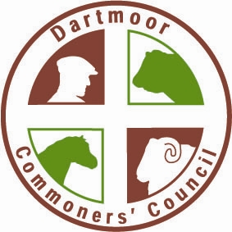
DARTMOOR COMMONERS’ COUNCIL
NOTICE OF COMMONERS’ ELECTION MEETINGS
Notice is hereby given that Commoners’ Election Meetings will be held for the purpose of electing members to the Dartmoor Commoners’ Council as follows:
North Quarter
Monday 15 June 2026 – 7:00 p.m – 8.00 p.m
Meldon Reservoir, Dartmoor National Park Car Park, Okehampton, EX20 4LU
Vacancies: 2 Members representing those persons whose names are recorded in the Commons Register as grazing not less than 10 livestock units
South Quarter
Tuesday 16 June 2026 – 7:00 p.m – 8.00 p.m
Venford Reservoir, Dartmoor National Park (East) Car Park, Nr Holne, TQ13 7SJ
Vacancies: 2 Members representing those persons whose names are recorded in the Commons Register as grazing not less than 10 livestock units
East Quarter
Wednesday 17 June 2026 – 7:00 p.m – 8.00 p.m
Haytor, Dartmoor National Park Lower Visitor Centre Car Park, TQ13 9XT
Vacancies: 2 Members representing those persons whose names are recorded in the Commons Register as grazing not less than 10 livestock units
West Quarter
Thursday 18 June 2026 – 7:00 p.m – 8.00 p.m
Pork Hill Car Park, Dartmoor National Park, Tavistock, PL19 9JU
Vacancies: 2 Members representing those persons whose names are recorded in the Commons Register as grazing not less than 10 livestock units
Eligibility:
Only those persons whose names are recorded in the Commons Register and who have paid the contributions required under section 16 of the Dartmoor Commons Act 1985 in respect of the current financial year are entitled to vote.
Nominations:
Nominations of candidates must be made by written nomination delivered to the Secretary, Dartmoor Commoners’ Council, not less than 7 days before the date of the relevant Commoners’ Election Meeting, and must be supported by the written acceptance of the nominee.
Nominations should be sent to:
The Secretary
Dartmoor Commoners’ Council
1 Canal Road
Tavistock
PL19 8AR
Email: office@dartmoorcommoners.org.uk
Administrative Note:
Contributions must be paid in accordance with the Council’s arrangements. Contributions will not be accepted at the Election Meetings.
Voting:
Voting shall be conducted in accordance with the Council’s Standing Orders and the provisions of the Dartmoor Commons Act 1985.
Chairing of Meeting:
The meeting will be chaired by the Chair of the Council or their appointed representative.
This notice is issued by the Dartmoor Commoners’ Council in accordance with its statutory duties.
Signed:
Dru Butterfield & Sara Sloman
Joint Secretaries
Dartmoor Commoners’ Council
Date of Issue: 29 April 2026

